CLOUD COMPUTING – CC – 1

NAME : GIDIYON S

ROLL NO : 727721EUIT039

QUESTION NO 3 :

Create a S3 bucket for the following requirements :

1.Create a new S3 bucket in the region of “Stockholm”

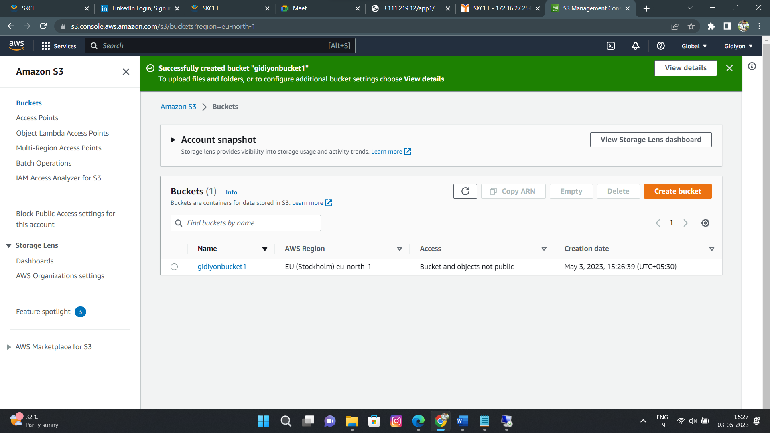

2.Make the bucket accessible to everyone (publicly) :

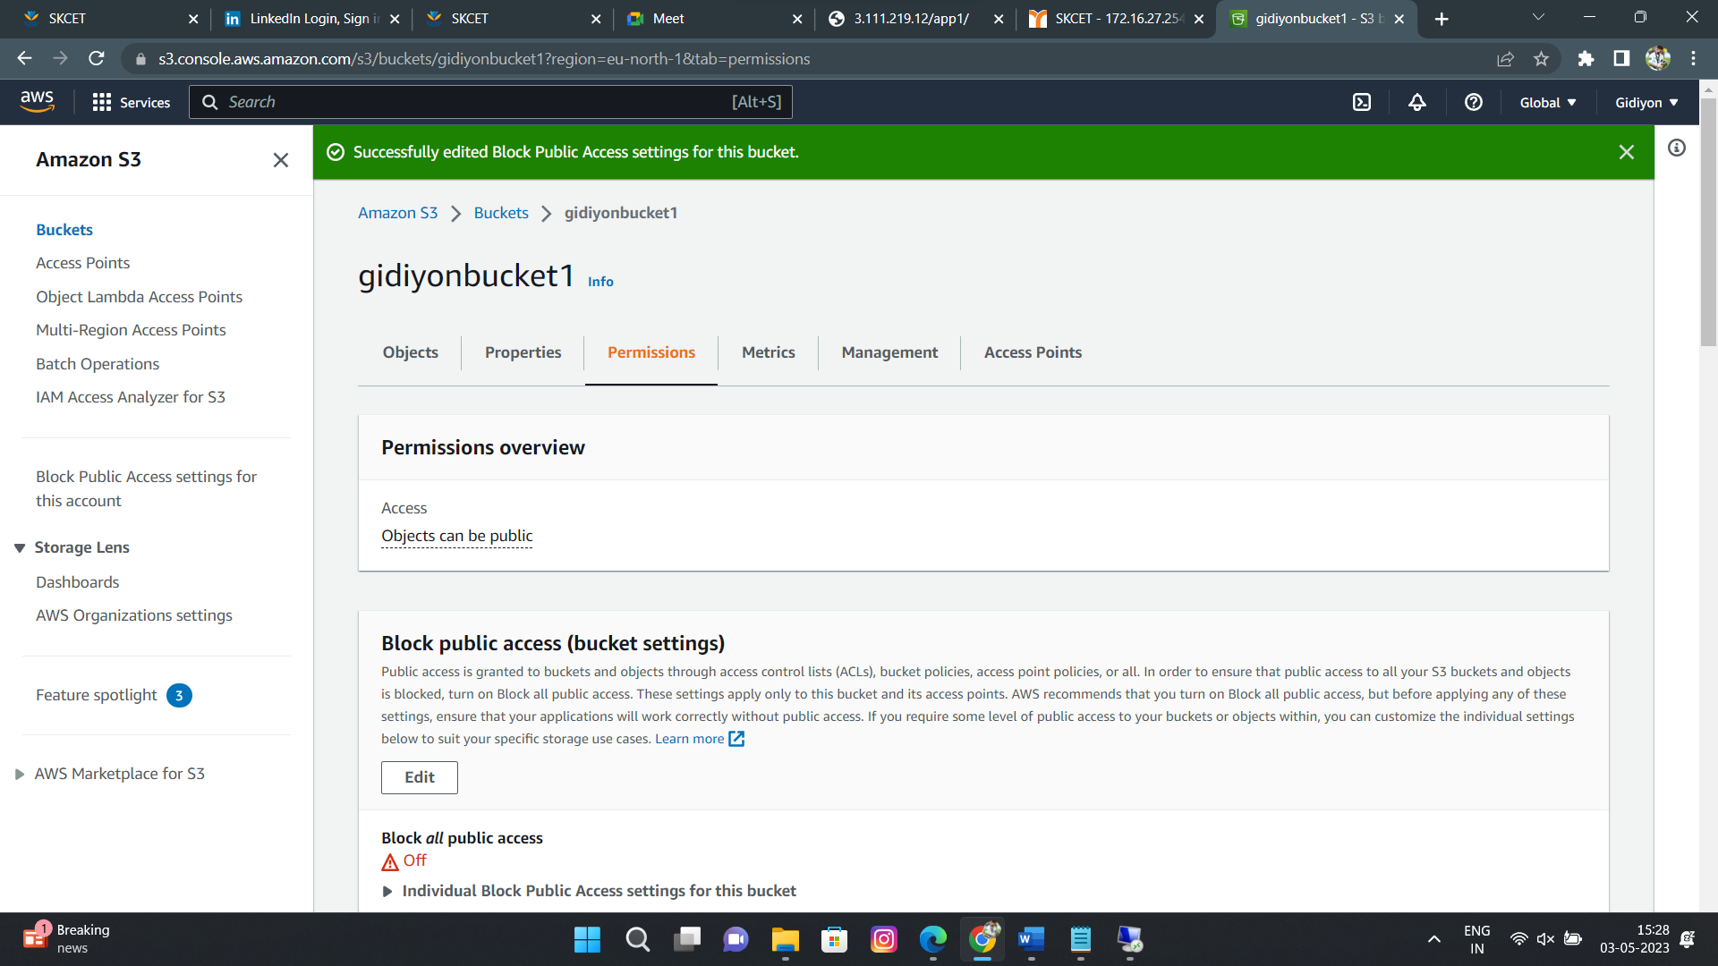

3.Upload a text file in the name of “accounts.txt” :

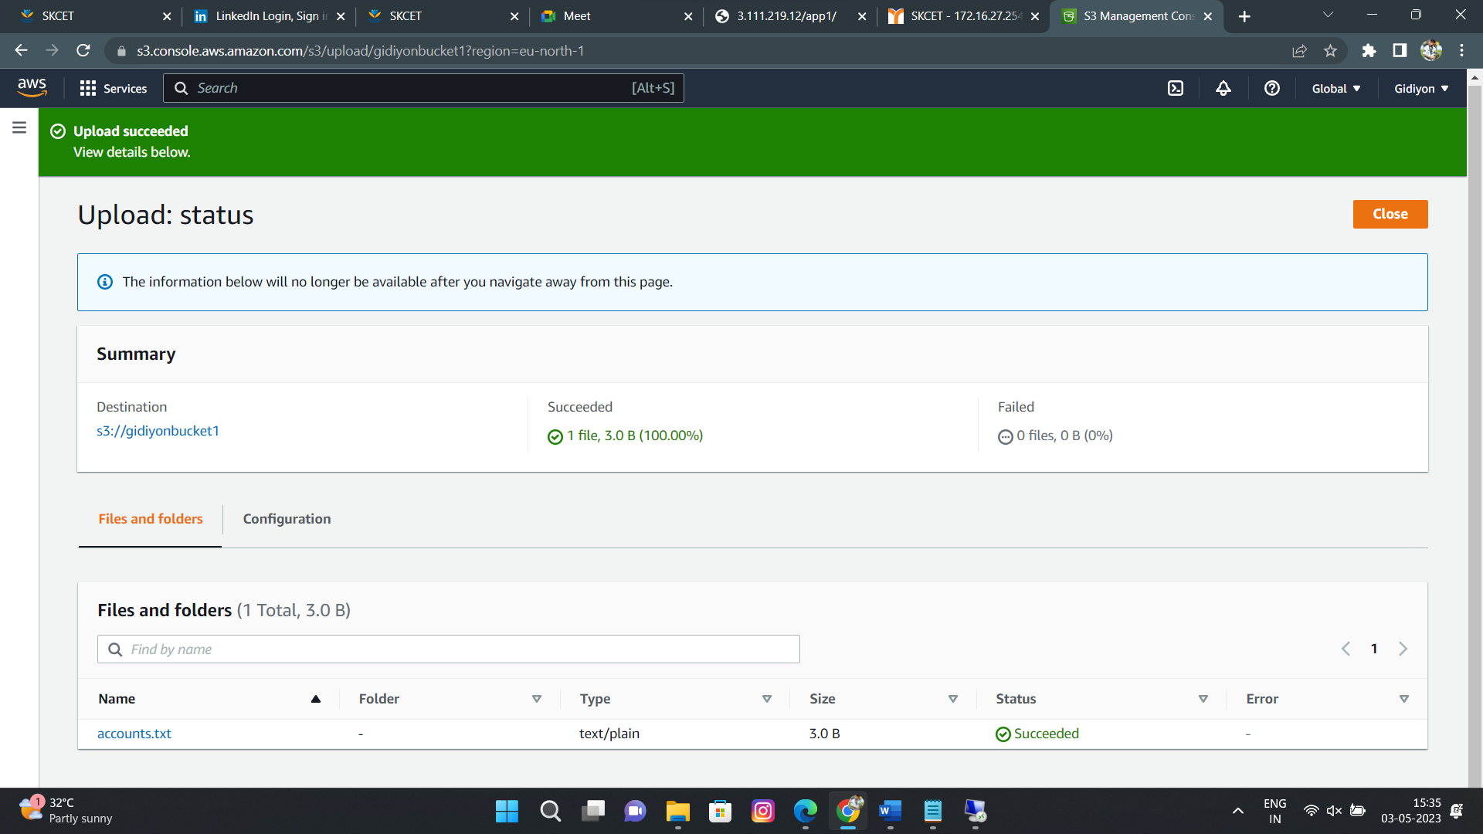

4.Make the “accounts.txt” accessible to everyone :

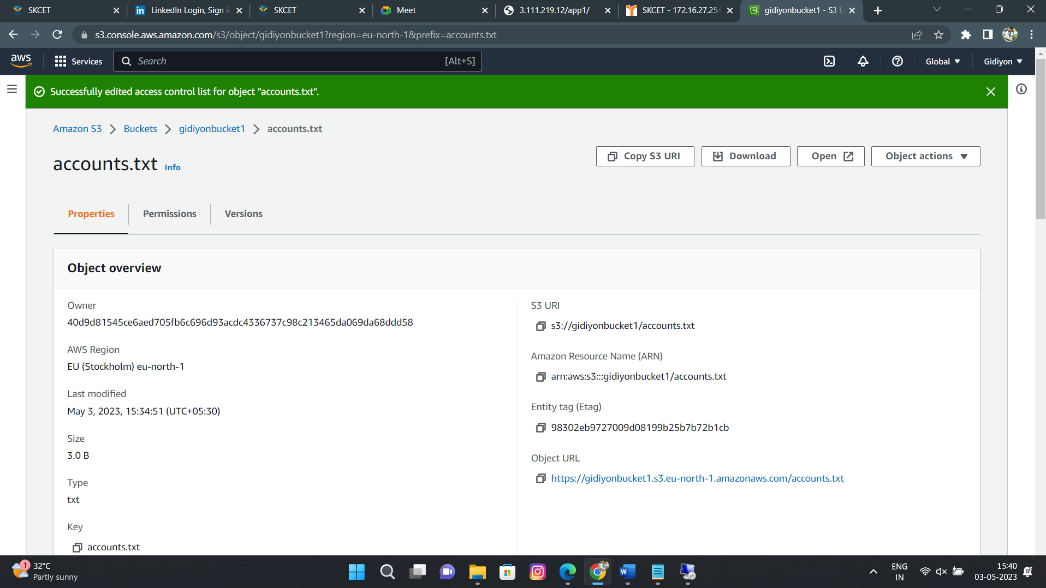

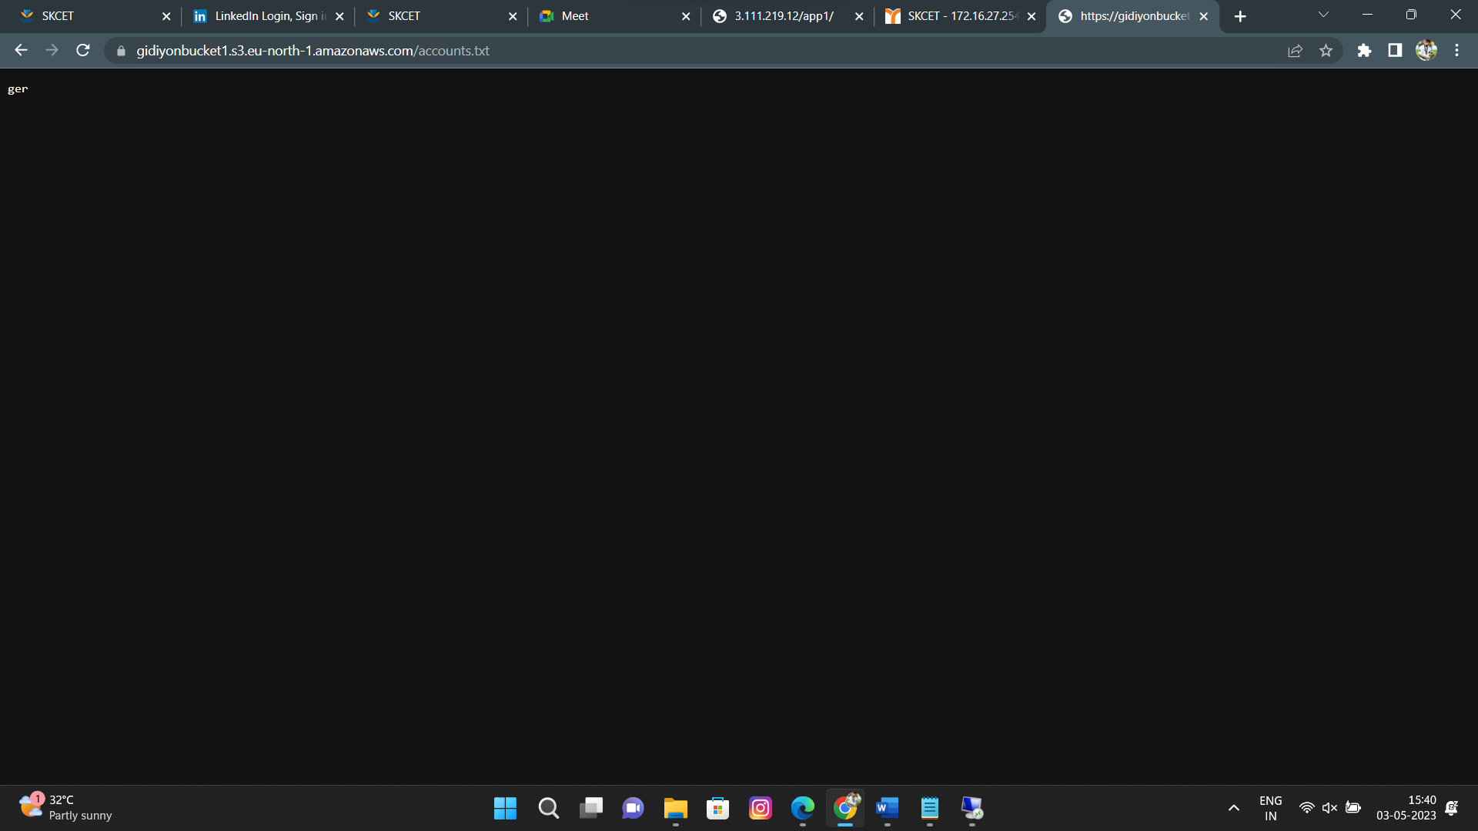

QUESTION NO 1:

Create an EC2 instance in the us – east – 1 region with following requirements :

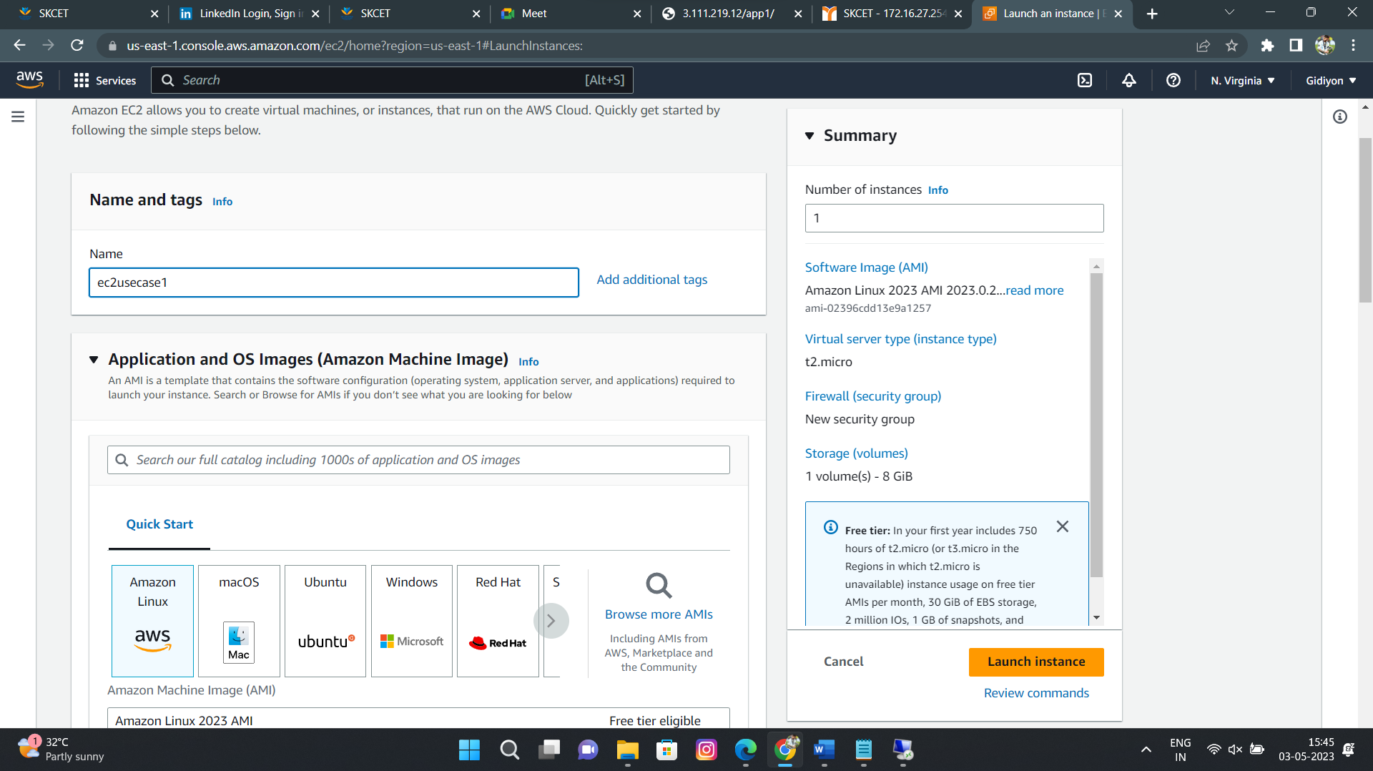

2.Give the name tag of both name and keypair as “ec2usecase2” :

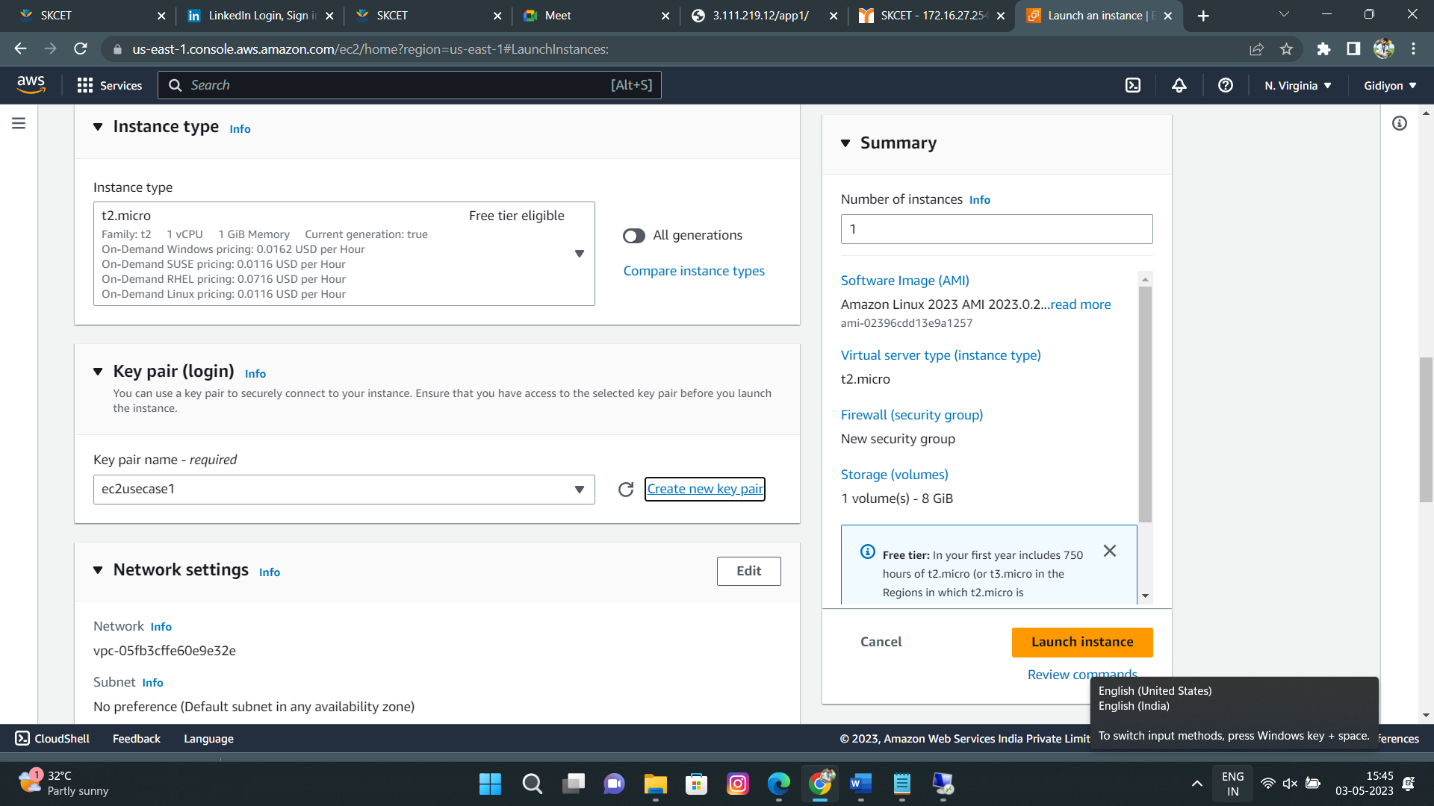

3.EC2 instance AMI should be “Amazon Linux 2 “ :

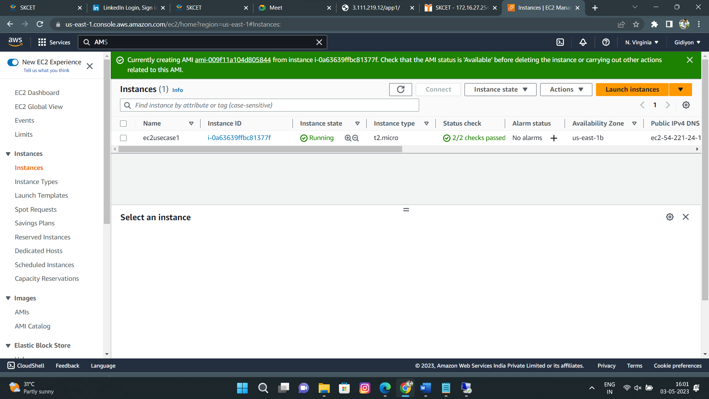

4.Allow HTTP Traffic from the internet :



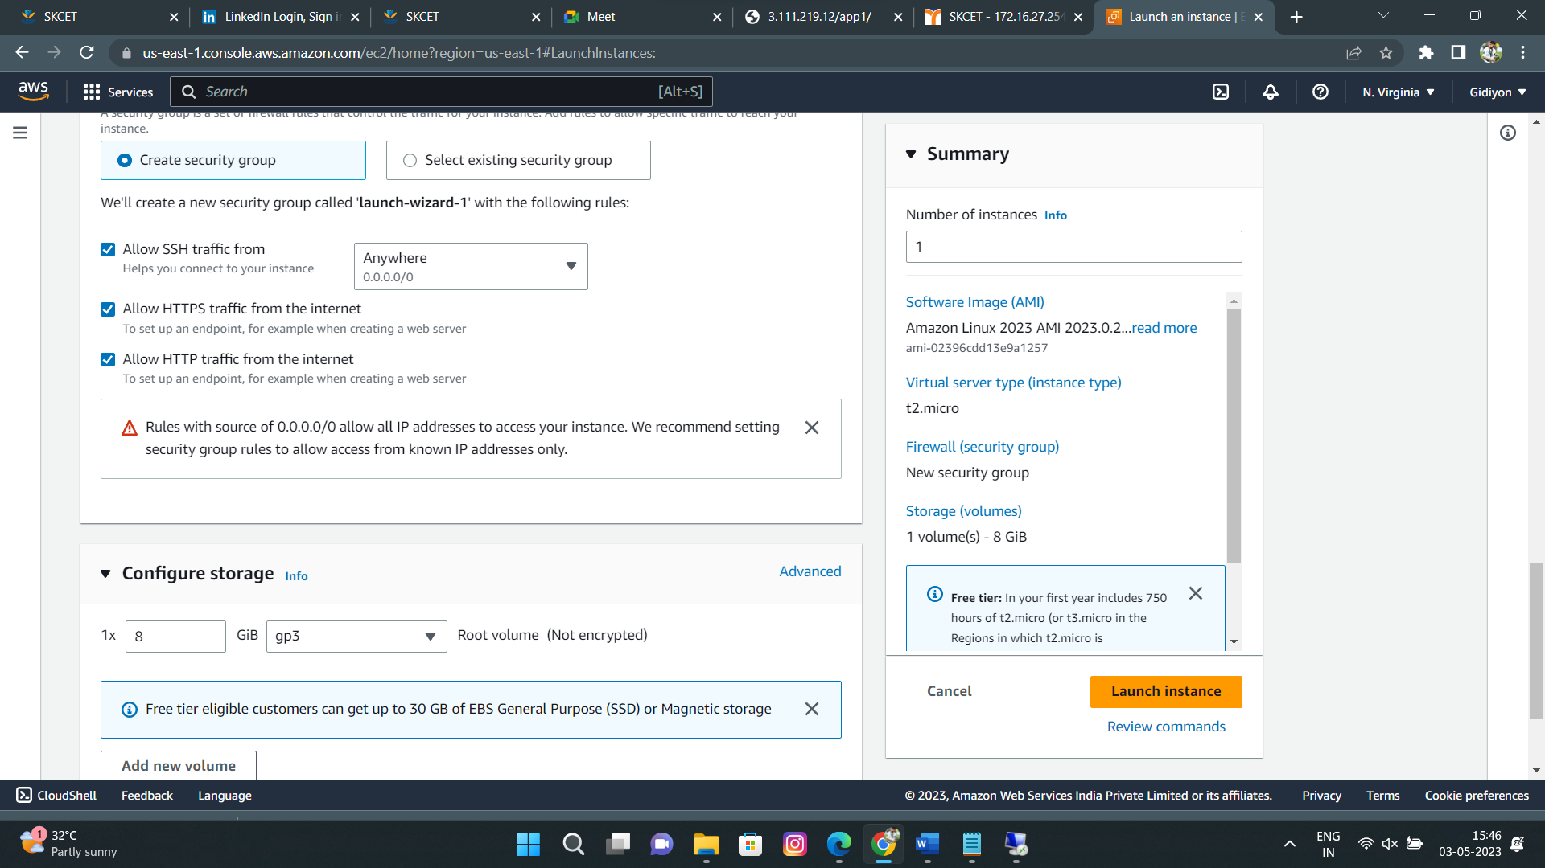

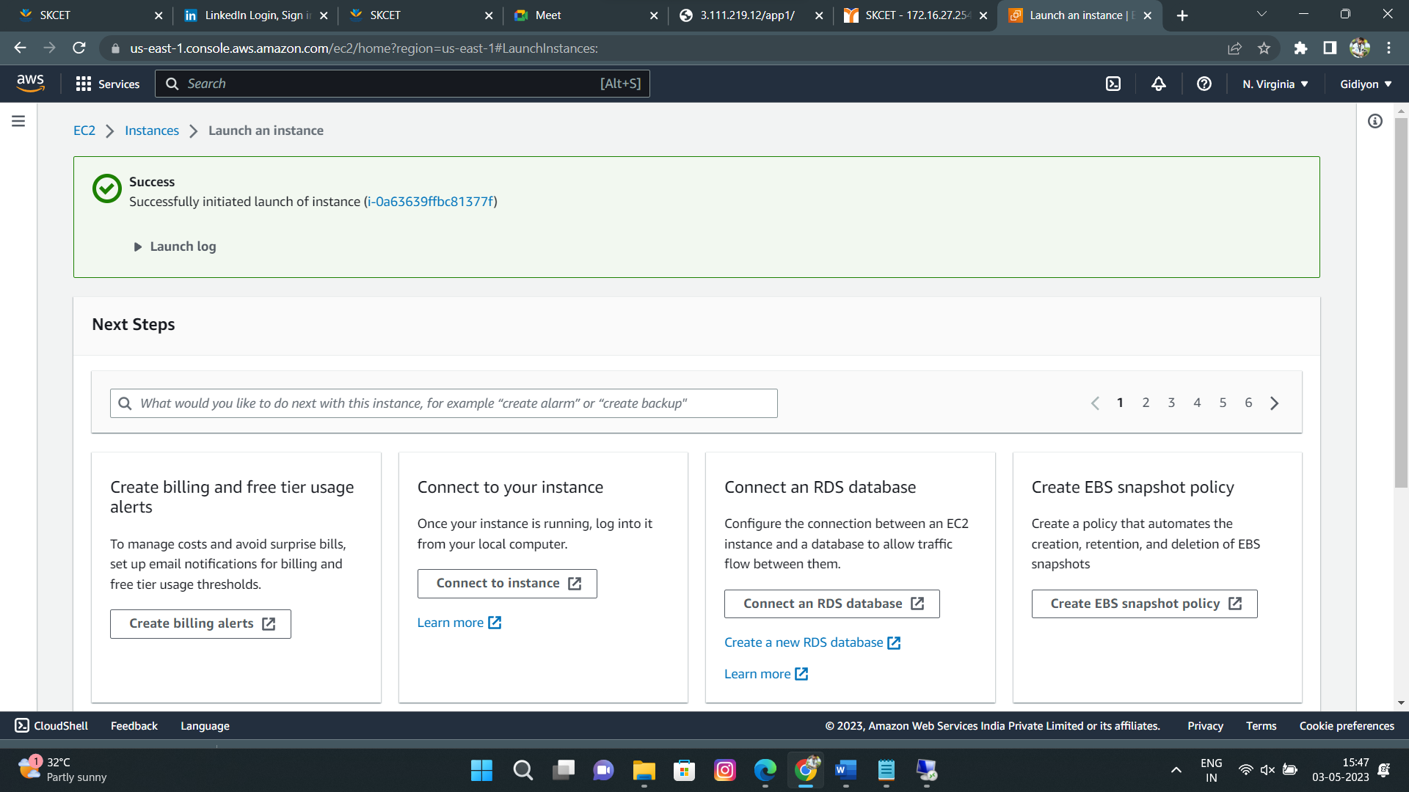

QUESTION NO 2:

The name of the IAM user should be Network-L1-User1 :

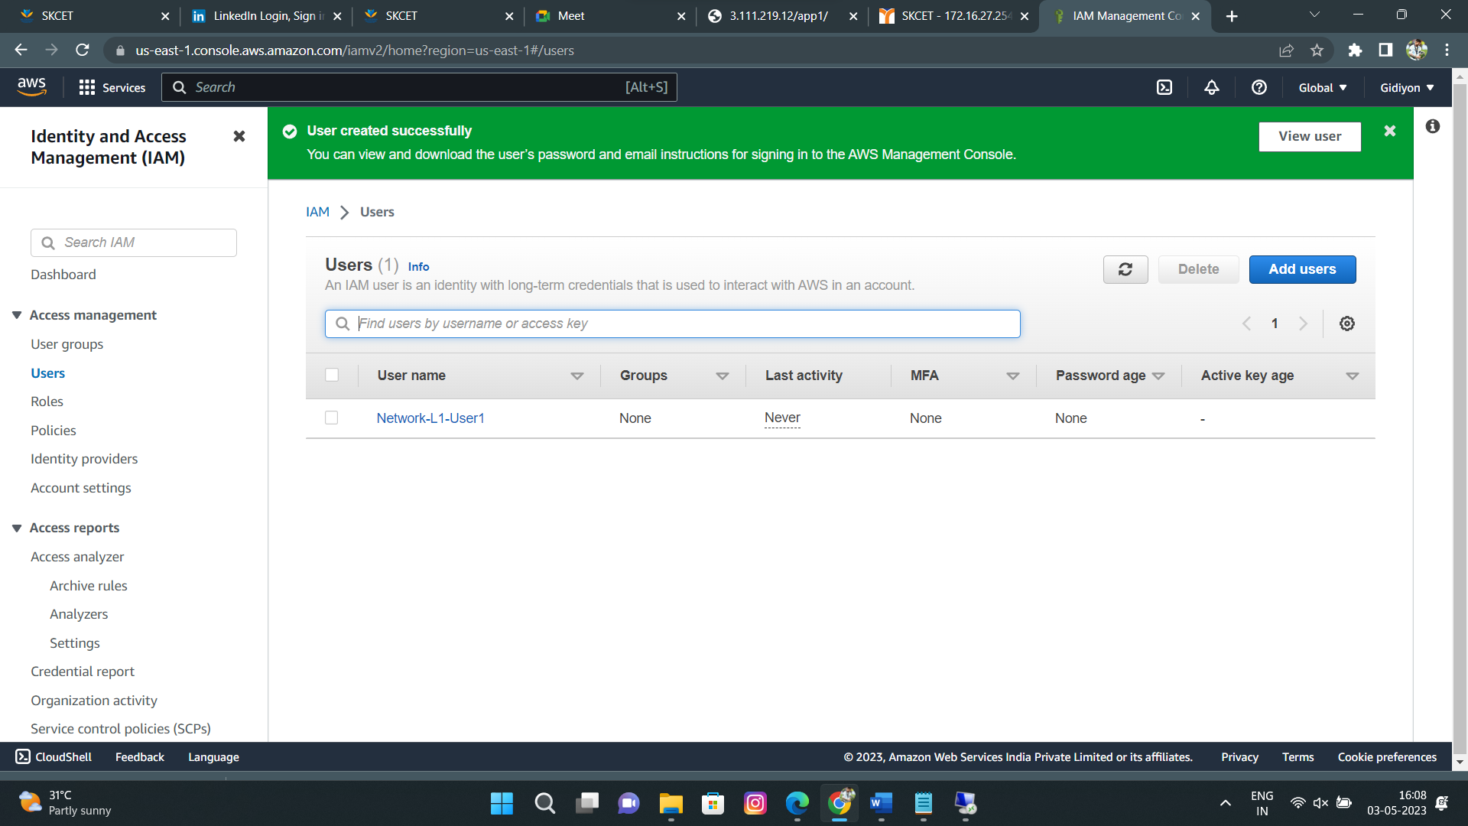

The name of the IAM team should be Network-L1-Team :

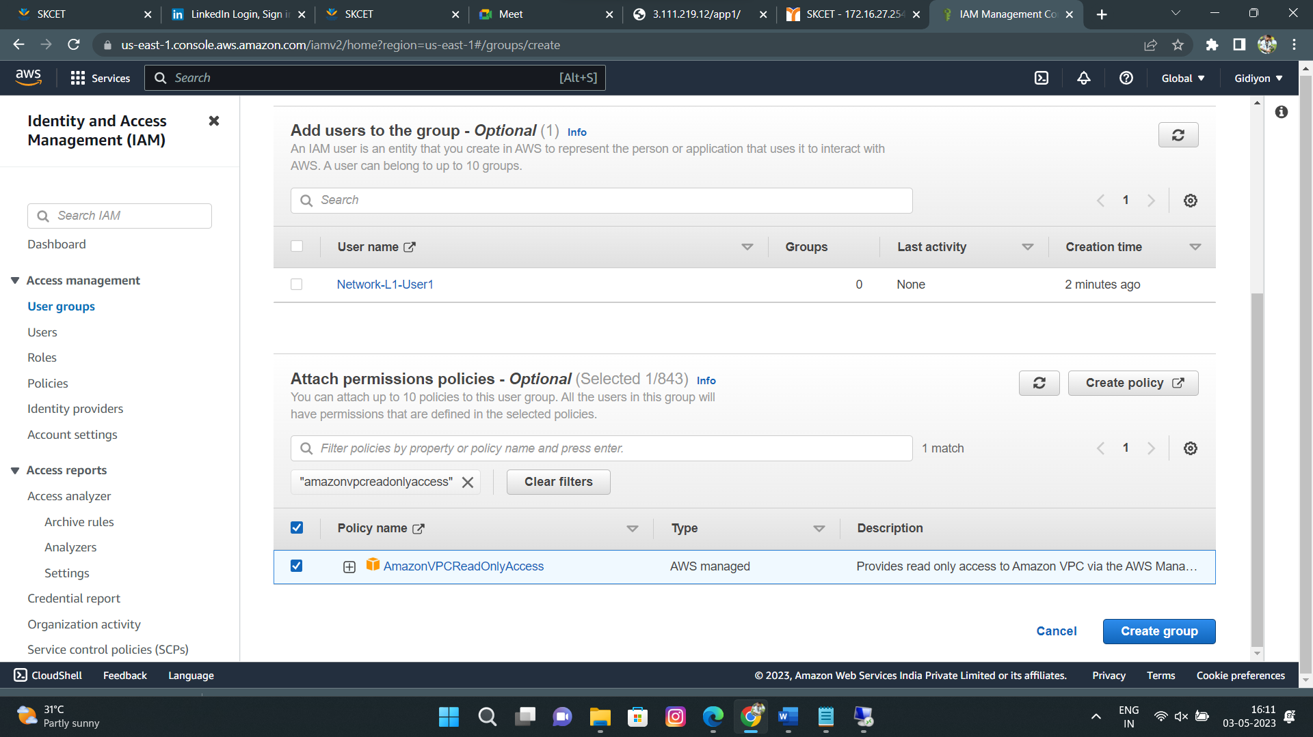

The AmazonVpcReadOnlyAccess policy be should be attached :

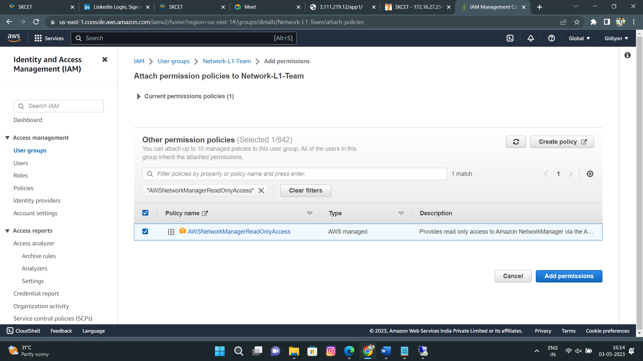

The AmazonNetworkManagerReadOnlyAccess policy be should be attached :

